6-2 Project One Submission: Network Modification Brief
Andree Salvo
Southern New Hampshire University
Cyb 210
Instructor: Bruce Gonzalez

2025
- Network Reconfiguration
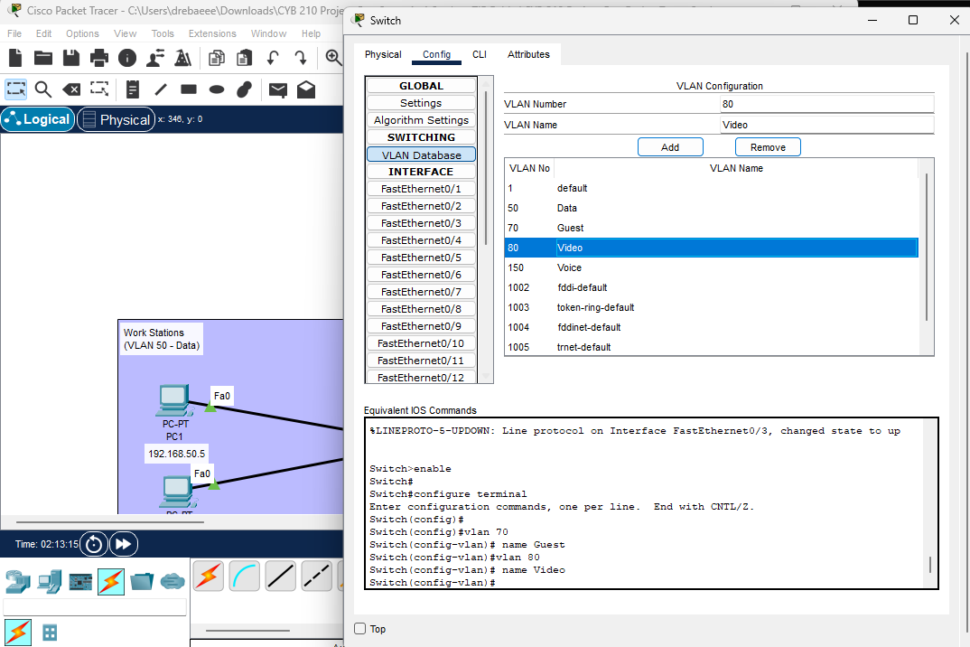
- Configure the VLAN for guest and video connections to meet the project requirements. Submit a screenshot of the VLAN table.
Explanation:
- Open the switch
- Click on VLAN Database
- Guest 70 was already preset for me so the only thing I had to add was “Video” which is VLAN 80

- Properly configure the guest wireless network to meet the project requirements. Submit a screenshot of the wireless settings for the wireless router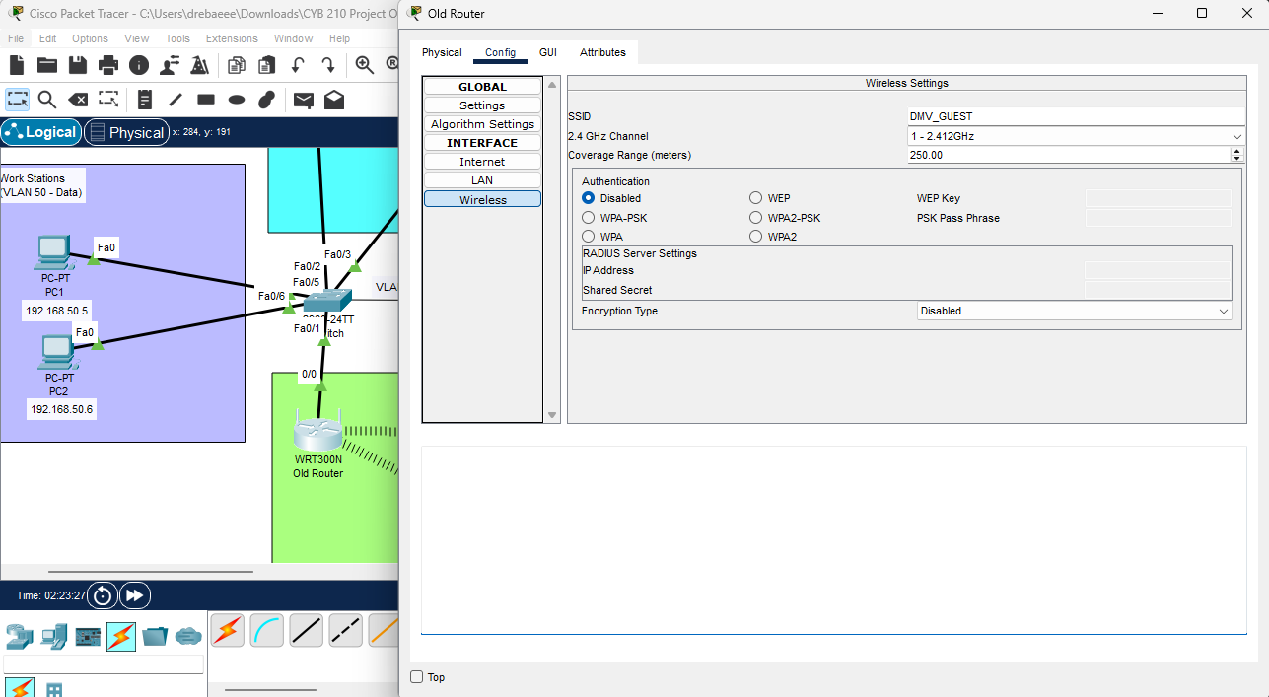
Explanation: To configure the guest wireless network, I did.
- Opened the Old Router
- Click the Config tab
- Wireless
- Renamed the “SSID” to “DMV_GUEST”
- Authentication > I disabled

- Make sure that devices are connected to the guest wireless network to meet the project requirements. IP addresses for the devices should be noted in the network diagram PNG or PDF
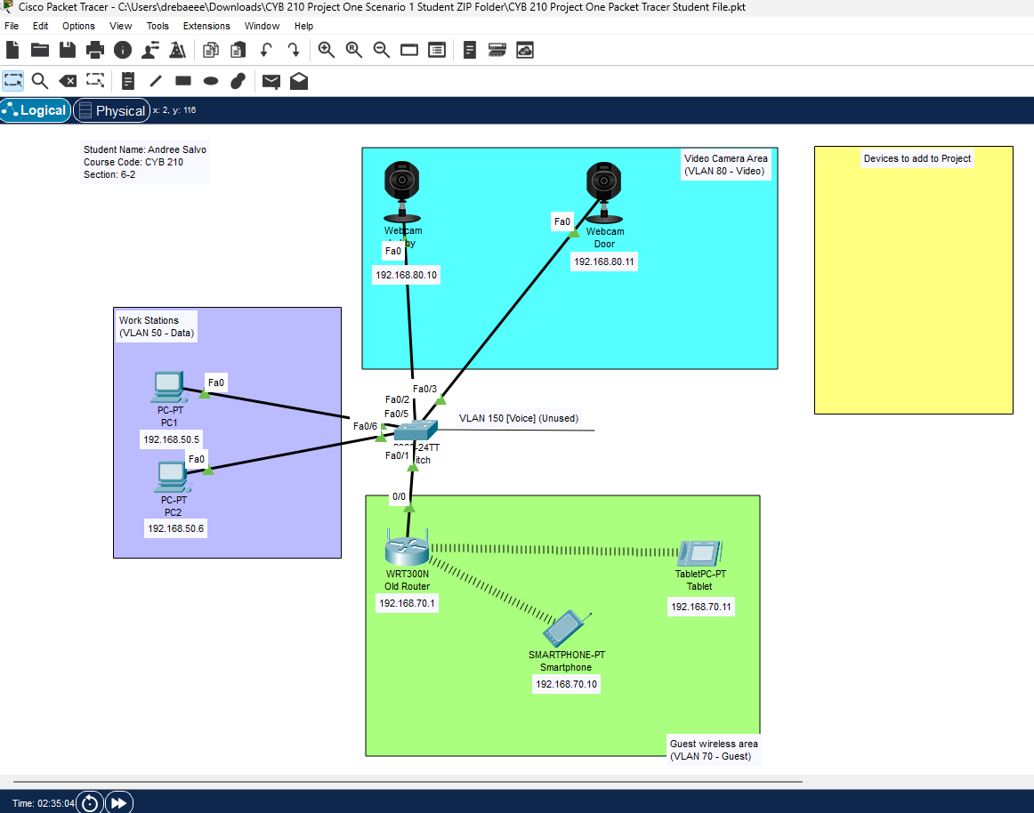

- Make sure that cameras are connected to the video network to meet the project requirements. IP addresses for the cameras should be noted in the network diagram PNG or PDF.
(Lobby Camera)
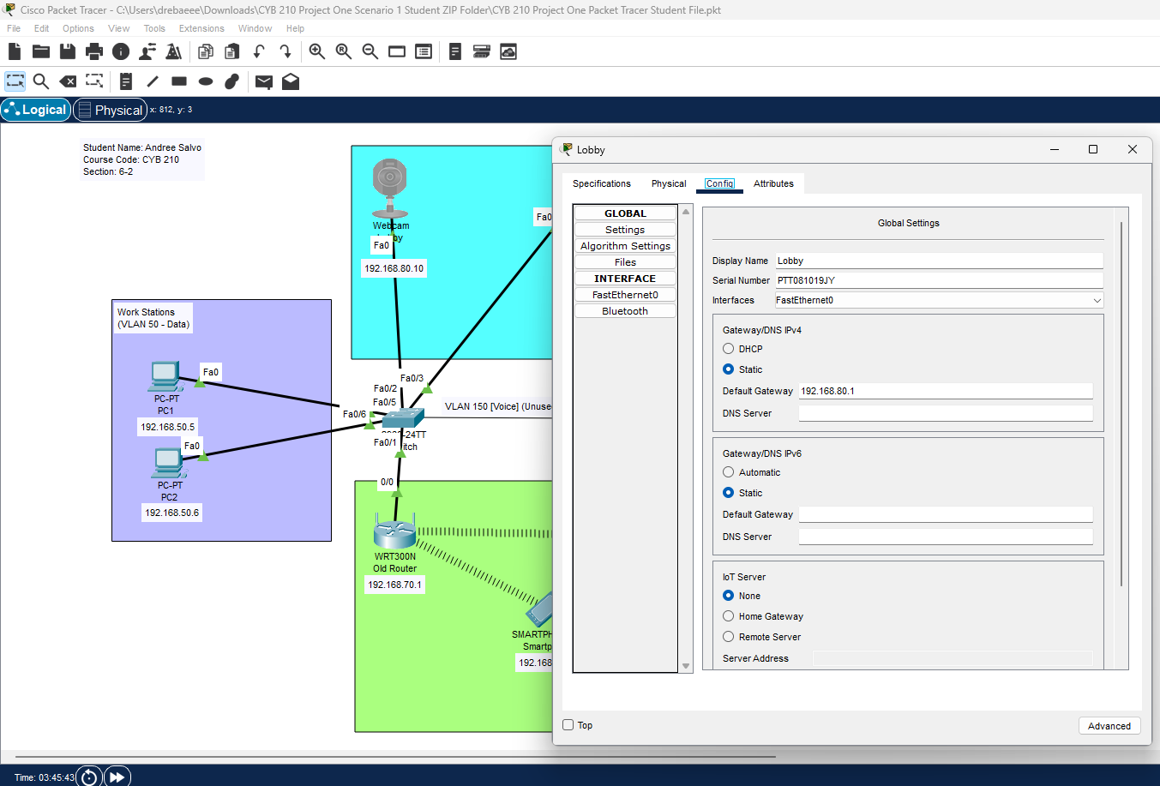

(Door Camera)
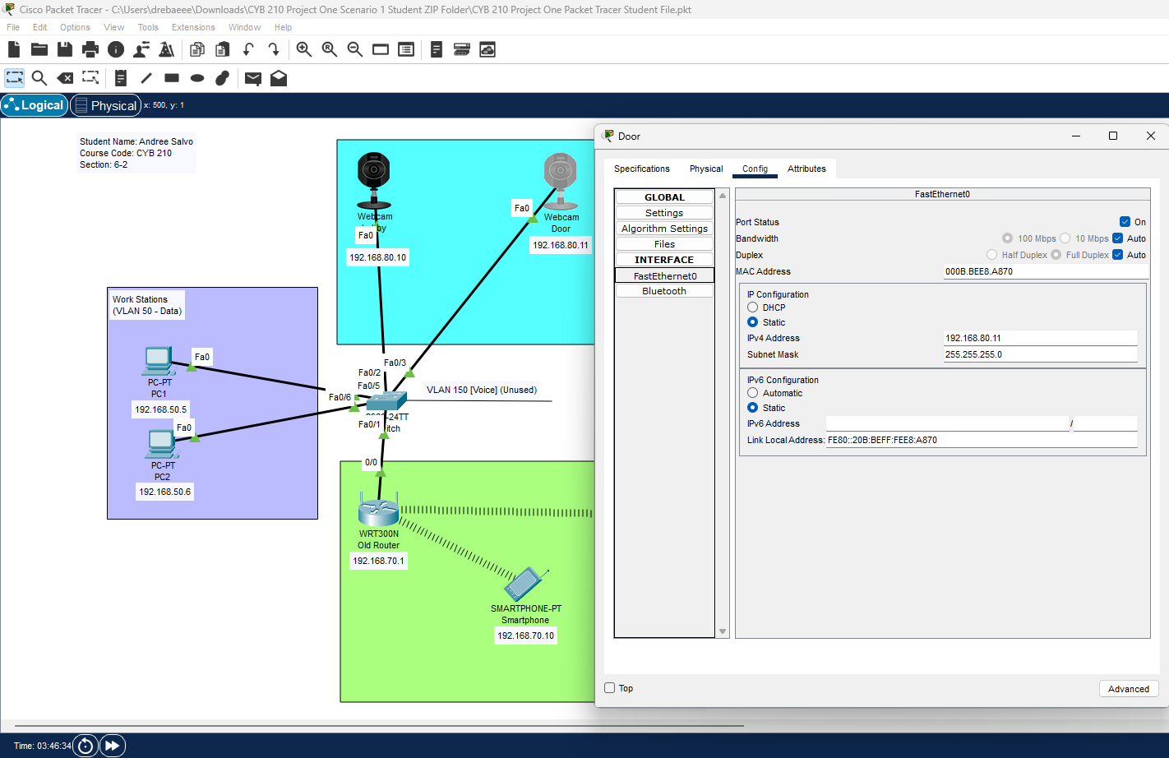

- Make sure that guest and video networks are properly segmented. Submit screenshots of ping tests that prove you have met this project requirement.
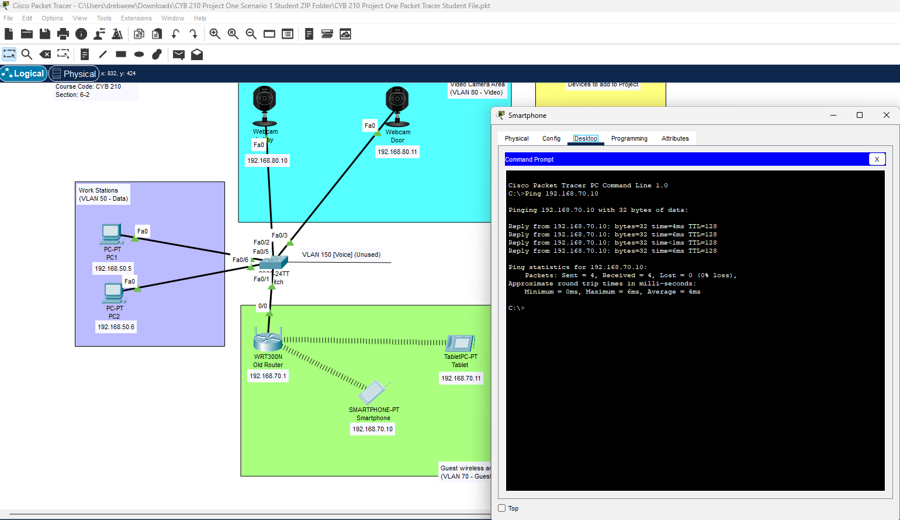
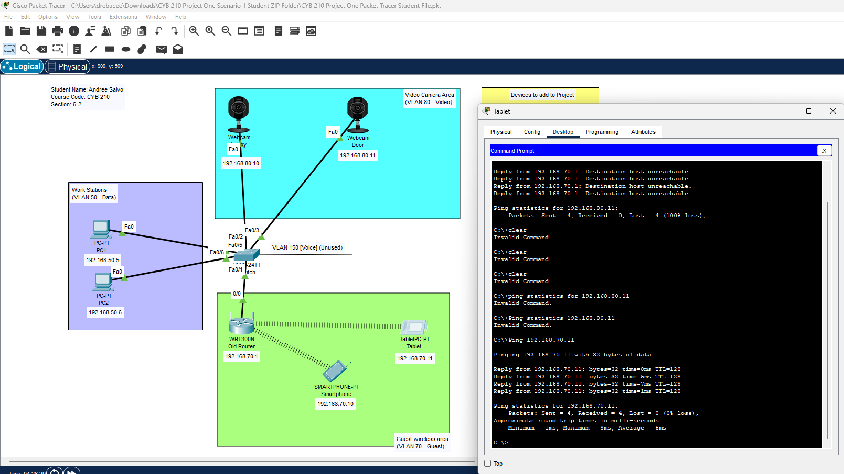
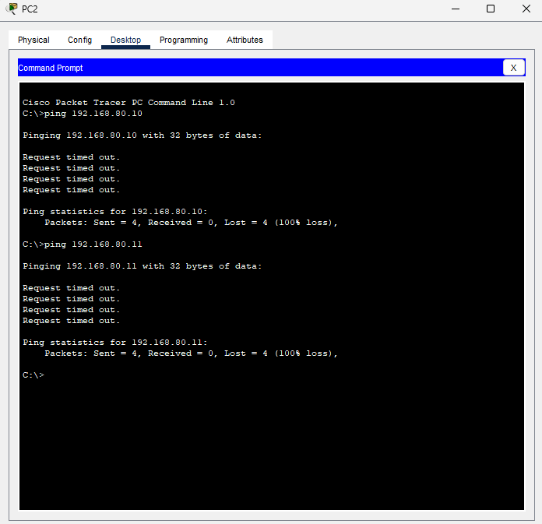

- Explanation of Network Segregation

- Describe how network traffic was segmented to meet the project requirements for guest and video connections.

Explanation: The switch segmented the network traffic by multiple VLAN databases. (1) VLAN 70, VLAN 70 is to be used for the guest, which connects to a wireless router, smartphone, and tablet. (2) VLAN 80 is for video. There were only two webcams for this scenario: "Lobby” and " Door.” (3) Lastly, VLAN 50 and 150 were already preset and were already segmented by two PCs. PC1 and PC2. VLAN 50 is data, and VLAN 150 is Voice. All four of these VLANs connect together by the switch, and all four work together differently.
- Explain how you considered the scalability of the guest wireless network in order to meet the project requirements (IP addressing, leasing, and so on).
Explanation: The scalability of meeting the project requirements allows up to 70 users to connect to a wireless network through the DHCP IP address. I did this from the Router’s GUI tab. Although the DMV may be slow, guests are not there for longer than 4 hours and cannot be connected to the guest network for a long.

